Context Level Diagram

Request
Knowledge Storm
STUDENT
Request
STUDENT

Request
Request
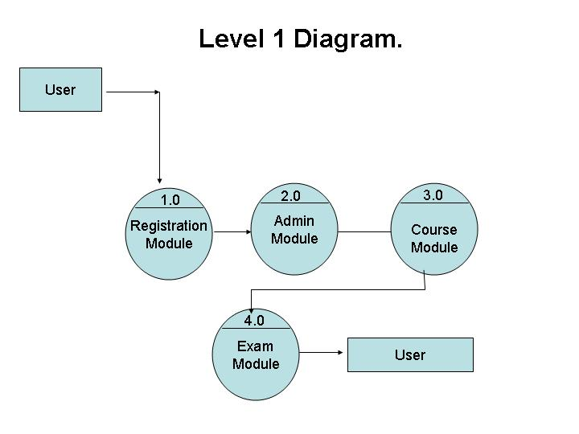

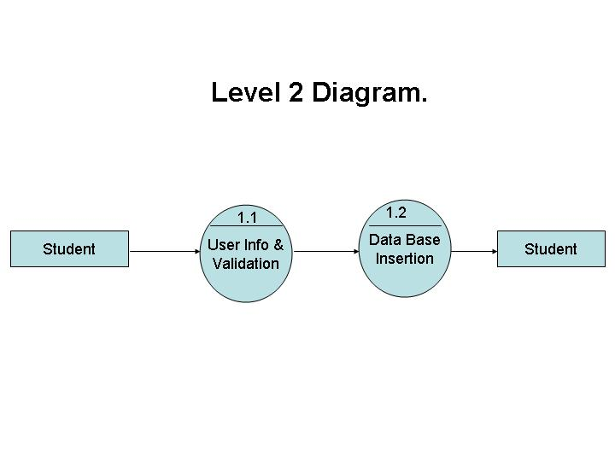

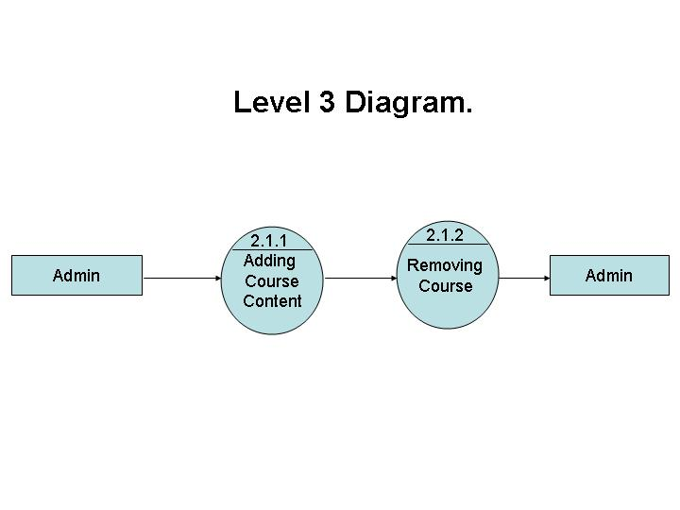

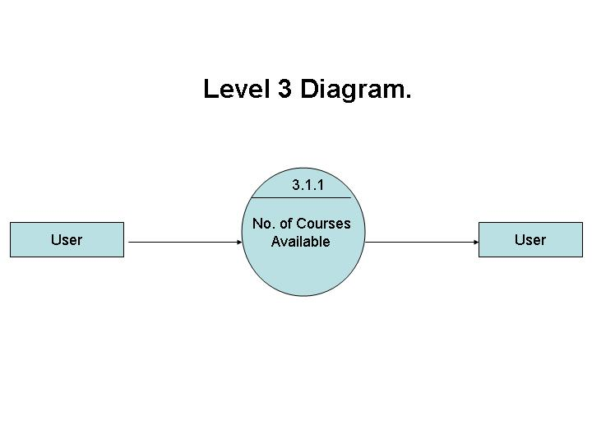

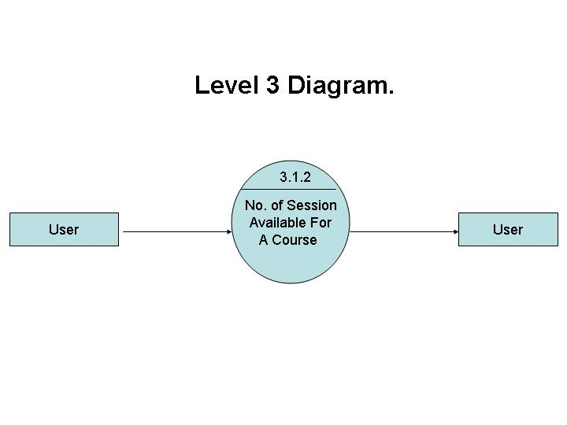

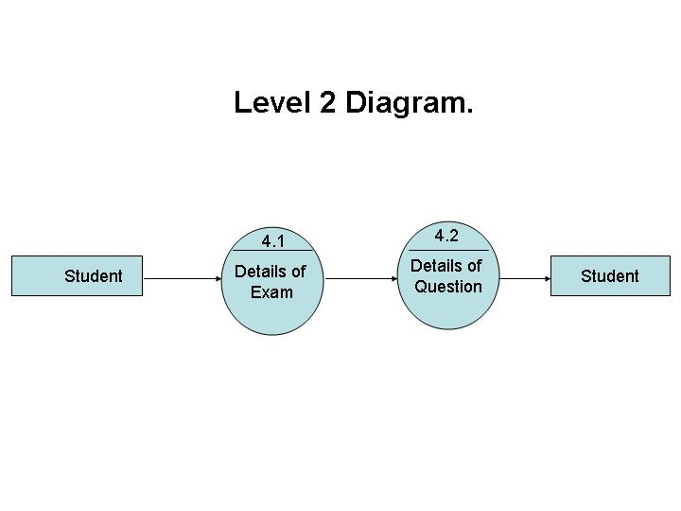

E – R Diagrams

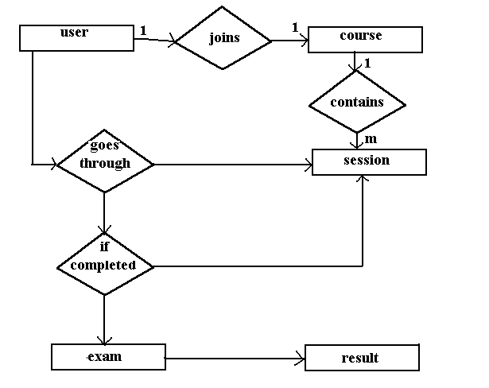

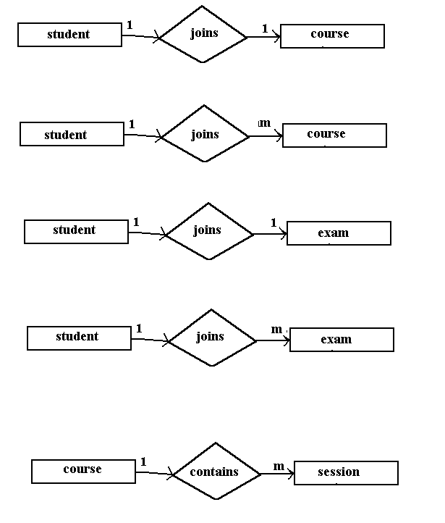

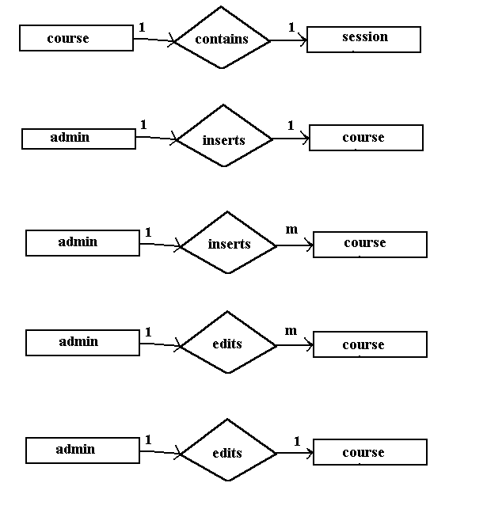

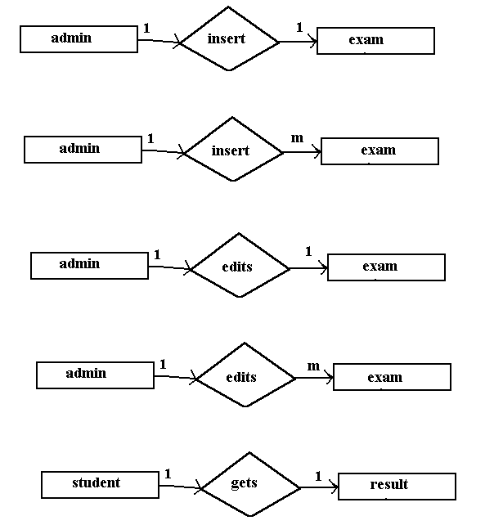

UML

Class Diagram

USERID
COURSEID
EXAMINATION

Registration()

CourseSelection()

Writingexamination()

User :

Object Diagram

User :

UseCase

KnowledgeStorm

Sequence Diagram

:Knowleadgestorm
:Checking
:Course selection
:writing exam
:Details

:Result

Registering

W
O
R
K
I
N
G

Feedback

End

StateChartDiagram

Enter into the site (new user)

Enter your details
Registration
Checking for authorisation
Writing examination
Course selection
Result

Enter id and password

Existing
user

Activity Diagram

Existing user
Enter into the site

New user
Enter your details
Enter id&password
Registration

Check constraints
Course selection
Write examination

Result
Exit from site

Not ok

ok

